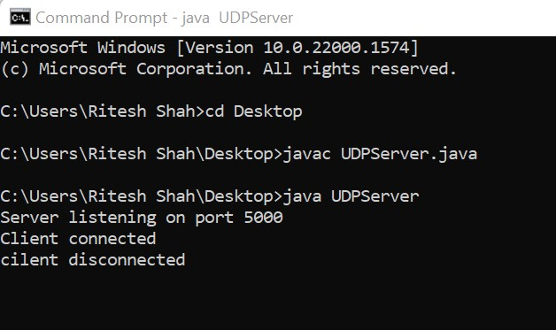

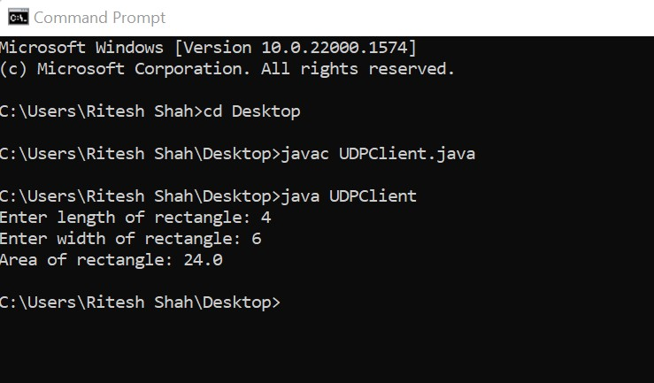

import java.io.\*;

import java.net.\*;

public class UDPServer {

public static void main (String[] args) throws IOException {

ServerSocket serverSocket = new ServerSocket (5000);

System.out.println("Server listening on port 5000");

while (true) {

Socket socket = serverSocket.accept() ;

System. out.println("Client connected");

BufferedReader in = new BufferedReader(new InputStreamReader(socket.getInputStream ())) ;

PrintWriter out = new PrintWriter(socket.getOutputStream () , true);

String lengthStr = in.readLine();

String widthStr = in.readLine();

double length = Double.parseDouble(lengthStr);

double width = Double.parseDouble(widthStr);

double area = length \* width;

out.println("Area of rectangle: " + area);

socket.close();

System.out.println("cilent disconnected");

}

}

}

import java.io.\*;

import java.net.\*;

public class UDPClient {

public static void main (String[] args) throws IOException {

String serverHostname = "localhost";

Socket socket = new Socket (serverHostname, 5000);

BufferedReader in = new BufferedReader(new InputStreamReader(System.in));

PrintWriter out = new PrintWriter(socket.getOutputStream () , true);

System.out.print("Enter length of rectangle: ");

String lengthStr = in.readLine();

out.println(lengthStr);

System.out.print("Enter width of rectangle: ");

String widthStr = in.readLine();

out.println(widthStr);

BufferedReader responseIn = new BufferedReader(new InputStreamReader(socket.getInputStream())) ;

String response = responseIn.readLine();

System.out.println(response);

socket.close();

}

}